IoT Management System
Software Architecture Design Document
Document ID : [IoTMS_Design_001]

2 Team
Jonghyun Han
Youk Kwon
Bohyun Jung
Dongog Min
Youngkeun Jang
Jinwook Hyun

Copyright © 2015 Team2 of CMU S/W Architecture Training Program. All Rights Reserved.

This document has been published for CMU Software Architecture Training Program by Team2. Team 2 cannot accept responsibility for any errors or omissions or for any loss occurred to any person, whether legal or natural, from acting, or refraining from action, as a result of the information contained herein. Information in this document is subject to change at any time without obligation to notify any person of such changes.

The this document cannot be used for any purpose other because this document is designed for educational purposes. Also, Team2 may have patents or patent pending applications, trademarks copyrights or other intellectual property rights covering subject matter in this document. The furnishing of this document does not give the recipient or reader any license to these patents, trademarks copyrights or other intellectual property rights.

No part of this document may be communicated, distributed, reproduced or transmitted in any form or by any means, electronic or mechanical or otherwise, for any purpose, without the prior written permission of Team2.

The document is subject to revision without further notice.

All brand names and product names mentioned in this document are trademarks or registered trademarks of their respective owners.

Document Information
Team 2,
LG Electronics,
Software Architecture Training Program,
Software Engineering Institute(SEI)
Carnegie Mellon University.

Contact us: jonghyun.han@lge.com

About This Document

Revision History
Version | Date | Comment | Author | Approval
0.1 | 2015-06-21 | Document outline | Dongog Min

Purpose
This document describes architecture of IoT Management System.

Scope
This document includes overall and sub system architecture as follows
- Description of the Project Context
- The Architectural Drivers
- The Views
- Design decisions and rationale
- Description of how the system will satisfy the QAs

Audience
This document’s audiences are as follows
- All Stakeholders
- Project Manager
- Architect
- Development Team

Related Documents
Following documents can be reference for understand this document.
Document ID | Comment
[IoTMS_TimeLog_001] | Time Log and Ear-value
[IoTMS_Interface_001] | Description Interface among components
Contents

1 Document Description 7
1.1 Purpose 7
1.1.1 Purpose and Scope 7
1.1.2 Audience 7
1.2 Document organization 7
1.3 Common notation 8
1.4 Terminology and definitions 8
1.5 References and relevant documents 9

2 Project Overview 10
2.1 Overview 10
2.2 Environment 10
2.3 Context 10
2.3.1 Market Context 10
2.3.2 Organizational Context 11
2.3.3 Business Context 11
2.3.4 Technological Context 12
2.4 Stakeholders 12
2.5 Relation with stakeholders 13

3 Architectural Drivers 14
3.1 High Level Functional Requirements 14
3.2 Use Cases 15
3.2.1 Use Cases 15
3.2.2 Use Case Scenarios 16
3.3 Constraints 21
3.3.1 Business Constraints 21
3.3.2 Technological Constraints 21
3.4 Quality Attributes 22
3.4.1 Quality Attribute Scenarios 22
3.4.2 Quality Attribute Utility 27

4 System Context 28

5 Overall Architecture Design 29
5.1 Architectural Style 29
5.1.1 Client-Server Architectural Pattern 29
5.1.2 MVC Architectural Pattern 29
5.1.3 Publish-Subscribe Pattern 30
5.2 Static Perspective 30
5.2.1 Static View of overall 30
5.2.2 Static View of 1st Decomposition 30
5.2.3 Design rational of Static Perspective 31
5.2.4 Tactics 31
5.2.5 Related Quality Attributes 31
5.3 Dynamic Perspective 31
5.3.1 Dynamic View of overall 32
5.3.2 Dynamic Behavior 32
5.3.3 Interfaces 32
5.3.4 The reason why we are use JSON 32
5.3.5 The reason why we are using Event-Bus 33
5.3.6 The reason why we are using DataBase 33
5.3.7 Tactics 33
5.3.8 Related Quality Attributes 33
5.4 Physical Perspective 33
5.4.1 Design Rationale of Physical Perspective 34
5.4.2 Develop Environment 34
5.4.3 Tactics 34
5.4.4 Related Quality Attributes 34

6 Decomposition of System Architecture Design 35
6.1 Dynamic view of Overall system 35
6.1.1 Dynamic view of overall system 35
6.1.2 Describe elements 35
6.2 Architecture design of Model 36
6.2.1 NodeManager 36
6.2.2 Architecture Design of RuleManager 37
6.2.3 Architecture Design of Logger 38
6.2.4 Architecture Design of Message 38
6.3 Architecture Design of UI and UI Controller 39
6.3.1 Static Perspective 39
6.3.2 Dynamic Perspective 39
6.3.3 Design Rationale 39
6.3.4 Related quality attributes 39
6.4 Architecture Design of Communication 39
6.4.1 Static Perspective 39
6.4.2 Dynamic Perspective 40
6.4.3 Design Rationale 40
6.4.4 Related quality attributes 40
6.5 Security 40
6.5.1 Secure communicate between User and User Interface 40
6.5.2 Secure communicate between IoTMS and SA-Node 40

7 Document Dictionary 41
7.1 Glossary 41
7.2 Acronyms 41
7.3 Index 41

Document Description

Purpose

Purpose and Scope
This document describes architecture of IoT Management System. Team2 (hereinafter Team2) was prepared this document for the Studio Project of the CMU Software Architecture Training Program. The purpose of this document is communication with stakeholders, and this document contains the following scope.
Scope
This document includes overall and sub system architecture as follows
- Description of the Project Context
- The Architectural Drivers
- The Views
- Design decisions and rationale
- Description of how the system will satisfy the QAs

Audience
This document was published for audiences are as follows
- All Stakeholders
- Project Manager
- Architect
- Development Team

Document organization
This document is organized as follows
Section | Description
Document Description | Describe overall of this document which includes Purpose, Notation, Terminology, Definitions and References.
Project Overview | Describe the project, purpose and scope. Also, Describe business, organizational, mission, or marketing concerns that are relevant to the project.
Architectural Drivers | Describe the architectural drivers for the system. The architectural drivers contains high level functional requirements, technical constrains, business constrains and quality attributes.
System Context | Describe context drawing of the system represents scope of the system, relationship to external entities.
Overall Architecture Design | Describe overall system architecture design in each perspectives which are static, dynamic and allocation. Also, Describe design decisions, rationale and how system to satisfy QAs.
Decomposition of System Design | Describe in-depth system architecture design in each perspectives which are static, dynamic and allocation. And describe communication I/F among each components. Also, Describe design decisions, rationale and how system to satisfy QAs.
Document Dictionary | Describe index, glossary, and acronym list.

Common notation
To do determine

Terminology and definitions
Terminology and definitions in this document are described.
Terminology | Description
IoT | Internet of Things
IoTMS | Internet of Things Management System
JSON | JavaScript Object Notation
JDBC | Java DataBase Connectivity
SQL | Structured Query Language
RSA | Rivest Shamir Adleman. The crypto algorithm based on Public-key
AES | Advanced Encryption Standard. The crypto algorithm based on Symmetric-key
EventBus | EventBus allows publish-subscribe-style communication between components without requiring the components to explicitly register with one another (ref. Google’s explain)
Guava | Google’s project. We are using this Library for EventBus
RM | RuleManager.
NM | Node Manager manage nodes. Node Manager add and remove node when new node is added or removed by User.
CM | Communication Manager
Link

References and relevant documents
Following documents can be reference for understand this document.
Document ID | Comment
[IoTMS_TimeLog_001] | Time Log and Ear-value
[IoTMS_Interface_001] | Description Interface among components
[IoTMS_WebAPI_001]
[IoTMS_TestCase_001]

Project Overview

Overview
Our Team is working for an organization that intends to enter the IoT market.
We make an Internet of Things(IoT) system that enables end-users to communicate with sensors and actuators installed in the home or business via PC or smartphone connected to the internet. (For example, indoor and outdoor light, temp and humidity sensor, door open-close actuator, door open-close sensor, secure alarm, presence/proximity sensor)

Environment
The home or business uses the internet with standard Wi-Fi router.
Sensors / actuators can connect to the home or business network with Arduino microcontroller enabled Wi-Fi.
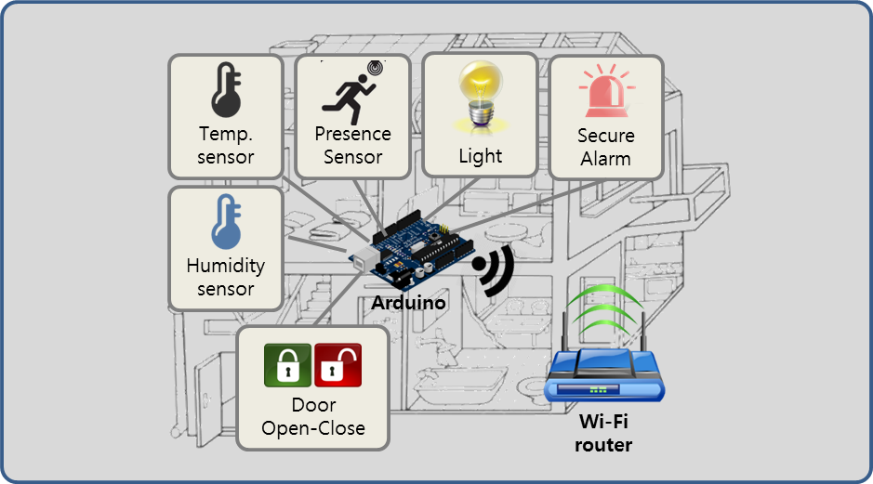
Figure 1. Environment of project

Context

Market Context
Market Context
Stakeholders | Customer, End-user, System Installer, Developer
System Access | Users want to access the system via PC, Mobile devices
Functional  expectations | After system installation, users expect the system to work  automatically by assigned rules of sensors and actuators
Environment | There are many vendors developing a system, sensors and actuators. But there is no standard of interface.
Table 1. Market Context

Organizational Context
Organizational Context
Roles and  responsibilities | Project Manager(includes planning, risk and configuration, schedule)  Architect  Requirement Manager  Test Manager  Documentation Manager  Developer (all members)
Technical  background | Digital-Appliance SW solution researcher & developer  Smart-phone SW developer  Camera module testing SW developer
Table 2. Organizational Context

Business Context
Business Context
Date of Delivery | 26 June 2015
Time Resources | 498 man-hours (48+450)  :48 man-hours (8 hours X 6 people) in Korea  :450 man-hours(3 hours X 6 people X 5 days X 5 weeks) in CMU
Strategy | Easy to use & high extensibility for sensors/actuators
Target Market | B2B - Building Architect Office, B2C - DIY User
Profit Model | Rental Service, Standalone, System Education, Maintenance
Future direction | Many kinds of sensors/actuators(indoor air quality sensor, camera, thermostat controller and so forth) is used & it makes a lot of use case. So big-data of these cases would enable to make services of IoT System.
Table 3. Business Context

Technological Context
Technical Context
Development  Skills | Java , C, JavaScript, HTML5
Platforms | Arduino Platform, Laptop Computers
Tools | Eclipse, Arduino IDE
OS | Windows, Linux
HW platform | Arduino , X86
Table 4. Technical Context

Stakeholders
Stakeholders of the IoTMS are follows
- Customer
- End-User
- System Installer
- Application Developer
- Hardware Developer
- Value-added-resellers (VARs)
- Service Provider
- Maintainer
- Project consultant (like mentor)

Relation with stakeholders
Below diagram is relation among key stakeholders and the IoTMS.
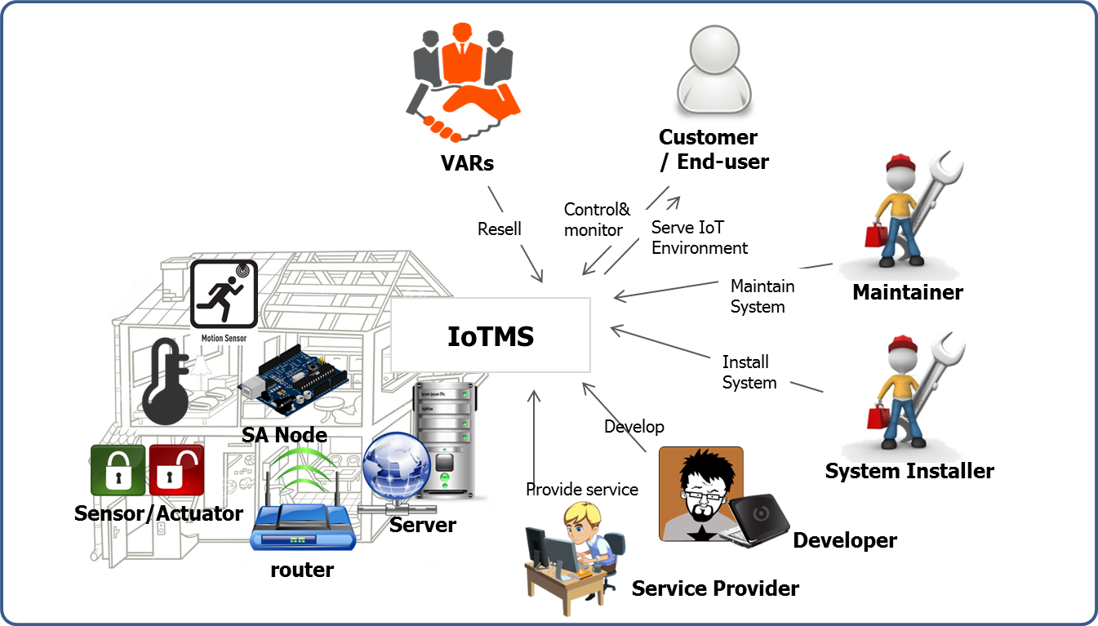
Figure 2. Relation with stakeholders

Architectural Drivers
In this section, this document describes high level function requirements extracted from project description document. And then, it describes use case scenario and use case diagram extracted from high level function requirement. Also, this document is explaining constraints and quality attribute.

High Level Functional Requirements
The high level functional requirements from project description document are as follows.
Req. ID | Description
FR-01 | The system provides a secure service (e.g. authentication, authorization, accounting) that allows users to query the home to find out how many nodes are installed and what sensors/actuators are installed on each node.
FR-02 | The system provides a secure service that allows users to determine the temperature/humidity, turn on and off lights, open and close the door, turn on the alarm, and determine if anyone is home.
FR-03 | The system should store sensor values and log all user commands for some period of time (e g. a configurable sliding window of data with 72 hours as the default value, minimum 8 hours) and allow user applications to review their sensor and command history in a secure and private way.
FR-04 | The system should not allow unauthorized persons to access the home sensors/actuators, or access any data generated by them, or any data stored in the system.
FR-05 | The system should not allow unauthorized persons to register a sensor that they do not own
FR-06 | The system should send an emergency message when the door is manually opened while alarmed or the house is suddenly occupied while alarmed.
FR-07 | The system should not allow automatic door opening while the house is alarmed. The alarm must be disabled prior to opening the door.
FR-08 | The system should send a message to the user to inform them when the house is vacant and not alarmed. It should ask them if they want to alarm the home. If they do not respond within 5 minutes (configurable, 5 minutes is the default value - feel free to shorten this to a few seconds for test and demonstration purposes) the house will lock itself. If a door is open, it will automatically close the door before alarming the house.
FR-09 | The system should automatically turn off the lights when no one is home and 10 minutes elapses (configurable, 5 minutes is the default value - feel free to shorten this to a few seconds for test and demonstration purposes).
FR-10 | It should be easy for users to add and remove nodes to and from the system without having to restart the system or other nodes (you will have to demonstrate this). This includes secure registration and recognition of the type of sensors and actuators provided by the node.
FR-11 | The system should make it easy for application developers (private persons, VARs, or other 3rd parties) to build custom apps, services, and/or make mashups from existing available services (you should describe how the design supports this).
FR-12 | The system should make it easy for developers to implement new protocol about new devices.
FR-13 | The system provides user define scenario service like IFTTT(IF This Then That)
FR-14 | When the system sends emergency message, it will be E-mail. In future, it can be SMS or tweet.
FR-15 | When sensors value is abnormal(out of range), the system sends an alarm message to user.
FR-16 | User sets configurations of E-mail address, logging-duration, secure response time and lights waiting time.
FR-17 | The system provides Web APIs for Web developer.
Table 5. High level function requirements

Use Cases
In this section, describe use case text, use case scenarios and diagram.

Use Cases
Below is use case text extracted from project description document.
Use case text
Do-It-Yourself(DIY) User buys IoT System and IoT products at Home Depot.
The user installs sensors and actuators at the proper place such like door, room, terrace and so on. Although the user doesn’t have any experience installing such devices, the user can install following user-manual.
And user installs IoT software in own PC. And then user connects SA Node to Internet router and registers the node in IoT Software after log-in.
After the registration, user checks sensors and actuators if they works or not.
In addition, user makes a custom rule and puts it into IoT system.
After all, user reviews sensors and command history.
Table 6. Use case text

Use Case Scenarios
Describe use case scenarios and diagrams are as follows.

UC-01: Query nodes and sensor/actuators

Use Case Title : Query nodes and sensor/actuators | Use Case ID : UC-01
General use case description:
This use case describes how to query nodes and sensors/actuators on each node information by user in a secure way
Entities involved:
User / IoT Management System(IoTMS)
Preconditions
User has registered in IoTMS using register menu
Primary use case flow of events:
1. User logs in IoTMS using by user’s ID and Password
2. IoTMS allows user to access System
3-1. User queries nodes information to IoTMS
A. IoTMS returns number of nodes to User.
B. User selects a node which user wants to know detailed information.
C . IoTMS returns sensors/actuators information in the node to User.
D. repeat B-C until user ends detailed query
3-2. User queries whole nodes information to IoTMS
A. IoTMS makes list of nodes and sensor/actuators within node
B. IoTMS returns list to User.
4. User logs out from IoTMS .
Primary use case post-conditions:
User querying is completed
Alternate use case #3-1
1. It is possible to query malfunction nodes and sensors/actuators each node.
Table 7. UC-01 Query nodes and sensor/actuators

Use case diagram

UC-02: Add new rule

Use Case Title : Add new rule | Use Case ID : UC-02
General use case description:
This use case describes how the system reacts by conditions previously defined
Entities involved:
IoT Management System(IoTMS)
Preconditions
User has logged in IoTMS .
IoTMS manages the list of predefined rule sets.
Primary use case flow of events:
1. User adds a new rule with conditions and actions to IoTMS.
2. Check whether the condition is unique and no collision with registered conditions.
3. If no issue on the condition, IoTMS accepts and applies the rule to predefined rule set.
4. IoTMS displays added rule set to User.
Primary use case post-conditions:
It is completed that new rule is inserted into predefined rules set.
Alternate use case #3-1
3.1. If the given condition is already existing or collision with other rules, IoTMS invokes error message with the reason.
Table 8. UC-02 Add new rule

Use case diagram

UC-03: Review histories of sensors/actuators state and user commands

Use Case Title : Review histories of sensors/actuators state and user commands | Use Case ID : UC-03
General use case description:
This use case describes how to review user’s sensor and command history by user in a secure way
Entities involved:
User
IoT Management System(IoTMS)
Preconditions
User has registered in IoTMS using register menu
Primary use case flow of events:
1. User tries to log in IoTMS using by user’s ID and Password
2. IoTMS allows user to access System
3. User requests sensors or commands history to IoTMS
4. IoTMS checks that user has permission
5. IoTMS asks period of history what user want to review to user
6. User sends period what user want to review
7. IoTMS makes list of history what user want
8. IoTMS displays list of sensors and commands history to user
Primary use case post-conditions:
User Reviewing history is completed
Alternate use case #5-1
5.1. If User cannot login because of incorrect ID/password, IoTMS displays “Find Password” or “Find User-ID” for User
Table 9. UC-03 Review histories of sensors/actuators state and user commands

Use case diagram

UC-04: Test control/monitor

Use Case Title : Test control/monitor | Use Case ID : UC-04
General use case description:
This use case describes how to test control/monitor sensors/actuators after log-in
Entities involved:
Secure service
Preconditions
User has already logged in IoT Management System(IoTMS).
Primary use case flow of events:
1. User tries to log in IoTMS using by user’s ID and Password
2. User monitors the temperature/humidity.
3. User turns on indoor light.
4. User turns on outdoor light.
5. User turns off indoor light.
6. User turns off outdoor light.
7. User controls door close.
8. User controls door open.
9. User monitors door sensors.
10. User monitors presence/proximity sensor.
Primary use case post-conditions:
User logs out to finish access the server.
Alternate use case #1-1
1.1 If user inputs wrong ID or password, system informs log-in fail.
Table 10. Test control/monitor

Use case diagram

UC-05: Register node

Use Case Title : Register node | Use Case ID : UC-05
General use case description:
Server register node.
Entities involved:
Installer, User(Customer), Server, Node
Preconditions
Server and node have same serial key.
Primary use case flow of events:
1. Installer or user request register node to server.
2. Server search node.
3. Server display node that can be registered.
4. Installer or user select node.
5. Server register the selected node.
Primary use case post-conditions:
Server and node can communicate with each other.
Alternate use case
3.1 if there is no node, display nothing.
3.2 if there is registered node, indicates that registered nodes
Table 11. Register node

Use case diagram

Constraints

Business Constraints
Following table describes business constraints.
ID | Description
B_CST-01 | Schedule Limitation: 7 weeks(include a plan-time in Korea)  498 man-hours (48+450)  :48 man-hours (8 hours X 6 people) in Korea  :450 man-hours(3 hours X 6 people X 5 days X 5 weeks) in CMU
B_CST-02 | Human Resources: 6 people
B_CST-03 | User can’t buy SA nodes and sensors/actuators separately.
Table 12. Business Constraints

Technological Constraints
Following table describes technical constraints.
ID | Description
T_CST-01 | End-user communicates with sensors/actuators via PC or Smartphone connected to the Internet.
T_CST-02 | An SA node has 1 or more sensors/actuators.
T_CST-03 | An SA node uses Wi-Fi communication(802.11)
T_CST-04 | The IoTMS should be made by Java Language & Arduino device
T_CST-05 | The IoTMS works on PC or Server
Table 13. Technological Constraints

Quality Attributes
In this section, describe quality attributes and quality attribute scenarios.
The quality attributes of this project are as follows.
ID | QA Type | Description
QA-01 | Availability | Server recognizes malfunction of sensors within 10 seconds.
QA-02 | Usability | All function of System is served in 3 depth UI.
QA-03 | Scalability | IoT Management System is limited to 50 SA Nodes.
QA-04 | Modifiability | Emerging new protocol, it is possible to be developed in 2 man-months.
QA-05 | Security | IoT Management System allow only authorized user to access in secure way.
QA-06 | Testability | 80% of test cases can be tested within 1 day.
QA-07 | Performance | The response time of controlling and monitoring is within 10 seconds.
QA-08 | Availability | Detect and notify Logging failure in 30 seconds.
Table 14. Quality attributes

Quality Attribute Scenarios
Followings are quality attribute scenarios represented by six-part scenario. These quality attributes must be considered when designing system architecture.

QA-01: Sensors availability

Scenario Title:  Availability | Scenario ID: QA-01
Raw Quality Attribute  Description: | Sensors availability
Source of Stimulus: | Sensors
Stimulus: | Sensor failure
Environmental Condition | The IoTMS has been installed and it works.
System Element: | • Sensors  • IoTMS
System Response: | If a sensor value is not between normal range, the IoTMS recognizes malfunction or fault of sensors. And then the IoTMS sends alarm message to user. (The normal values ranges are configured according to sensor datasheet.)
Significant Measures: | The IoTMS sends alarm message to user in 10 seconds after recognizing malfunction or fault of sensors in 3 times consecutively.
Table 15. QA-01 Sensors availability

QA-02: UI(User Interface) Usability

Scenario Title:  Usability | Scenario ID: QA-02
Raw Quality Attribute  Description: | UI(User Interface) Usability
Source of Stimulus: | User
Stimulus: | UI of IoTMS
Environmental Condition | The user has logged into the IoTMS.
System Element: | IoTMS
System Response: | When the user wants to change the settings of IoTMS or to get sensor value or to set actuator, the usage of UI should not be complicated.
Significant Measures: | UI depth is less than 3.
Table 16. UI(User Interface) Usability

QA-03: SA Nodes Scalability

Scenario Title:  Scalability | Scenario ID: QA-03
Raw Quality Attribute  Description: | SA Nodes Scalability
Source of Stimulus: | User(Installer, DIY user ..etc.)
Stimulus: | SA Nodes
Environmental Condition | IoTMS has one SA node.
System Element: | IoTMS
System Response: | SA node
Significant Measures: | When the user wants to add two or more SA node to their own IoTMS,  1. Install additional SA node in the home.  2. IoTMS find & connect additional SA Node on network.  3. complete.
Table 17. SA Nodes Scalability

QA-04: Communication protocol Modifiability

Scenario Title:  Modifiability | Scenario ID: QA-04
Raw Quality Attribute  Description: | communication protocol Modifiability
Source of Stimulus: | developer , 3rd party vendor , …etc
Stimulus: | communication protocol between IoTMS and SA node
Environmental Condition | Current IoTMS communicate with SA node unsing Wifi only.
System Element: | IoTMS
System Response: | new communication protocol SA node
Significant Measures: | Emerging new protocol, SW developer make/test/deploy new communication protocol module.
Table 18. Communication protocol Modifiability

QA-05: User access Security

Scenario Title:  Security | Scenario ID: QA-05
Raw Quality Attribute  Description: | User access Security
Source of Stimulus: | unauthorized user
Stimulus: | unauthorized user access to IoTMS
Environmental Condition | IoTMS is online.  IoTMS has a list of authorized users.
System Element: | IoTMS
System Response: | If the user is not in the list and tries to access to IoTMS , IoTMS dosen't allow login.
Significant Measures: | IoTMS never allow unauthorized user to access.
Table 19. User access Security

QA-06: SW module Testability

Scenario Title:  Testability | Scenario ID: QA-06
Raw Quality Attribute  Description: | SW module Testability
Source of Stimulus: | Test engineer , Test manager.
Stimulus: | SW module Test
Environmental Condition | SW module development time  SW module integration time  SW module deployment time  SW module run time
System Element: | SW module of IoTMS
System Response: | SA node
Significant Measures: | Test engineer test the quality of the software based on the test case.  , capture the results , feedback to the developers.
Table 20. SW module Testability

QA-07: IoTMS-SA node Response time Performance

Scenario Title:  Performance | Scenario ID: QA-07
Raw Quality Attribute  Description: | IoTMS-SA node Response time Performance
Source of Stimulus: | User
Stimulus: | User's direct request to SA node.
Environmental Condition | normal operation mode of IoTMS
System Element: | IoTMS  SA node
System Response: | When the user request to get sensor value,  1. IoTMS send the "get sensor value" message to SA node .  2. SA node measure sensor value.  3. SA node send "sensor value" message to IoTMS.  4. IoTMS display "sensor value".  When the user request to set actuator status,  5. IoTMS send the "set actuator status" message to SA node.  6. SA node set actuator.  7. SA node send "complete actuator control" message.  8. IoTMS display "actuator status".
Significant Measures: | The response time of controlling(System Response 5~8) and monitoring(System Response 1~4) SA node is within 10 seconds.
Table 21. IoTMS-SA node Response time Performance

QA-08: Logging history availability

Scenario Title:  Availability | Scenario ID: QA-08
Raw Quality Attribute  Description: | Logging history availability
Source of Stimulus: | Disk space
Stimulus: | The logging module fails to work when the disk space is full .
Environmental Condition | Logging module is logging history to Disk .
System Element: | Logging Module (SW)
System Response: | Disk (HW)
Significant Measures: | IoTMS detect and notify Disk Full to administrator
Table 22. Logging history availability

Quality Attribute Utility
// Most priority QAs

System Context
The System context diagram describes interaction among User, Node and IoTMS.
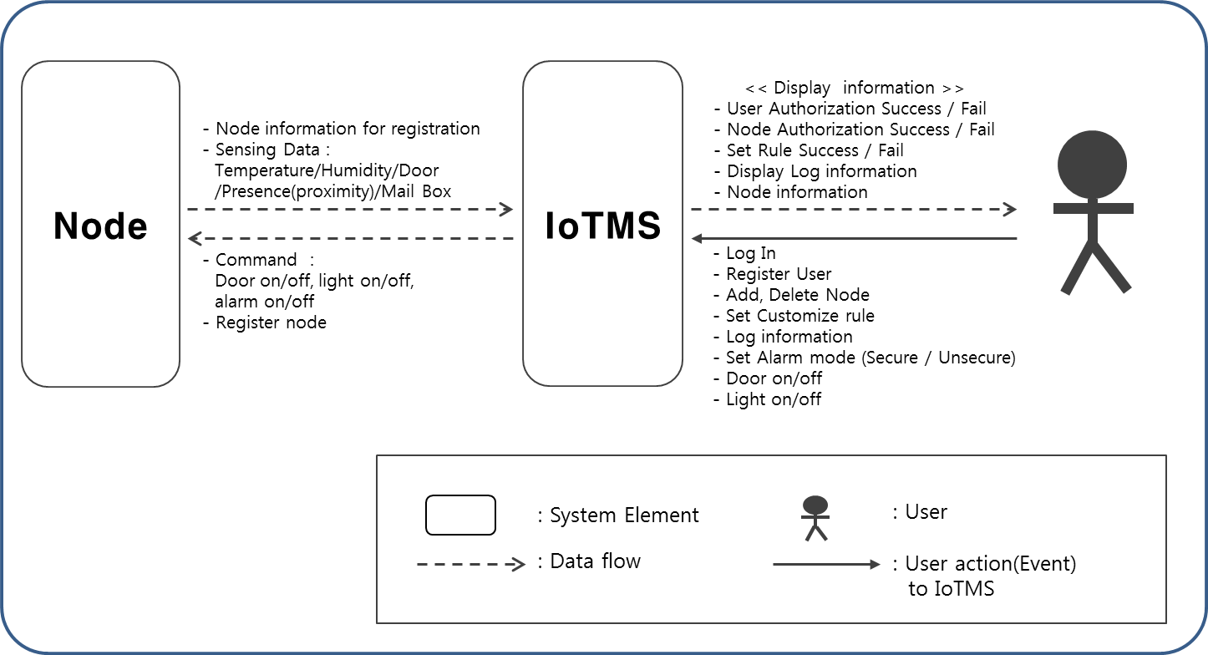
Figure 3. System Context Diagram

User are using IoTMS for adding/removing node, controlling actuators or sensors(e.g. Door open), setting alarm mode and so forth. Also, User can monitor sensor’s status via Internet. User should be required log-in to the IoTMS system when user want to see sensor’s status or control sensors or actuators.
Below describes each elements of system context diagram.

Element | Description
User | 실제 시스템을 사용하는 사용자이고, 로그인을 통해서 사용해야되고 어쩌구저쩌구
IoTMS | 전체 시스템이고, Node와 연결되어 있고, 사용자를 위해서 Interface를 제공하고, 블라블라
Node | SA-Node. 아두이노로 구성되어있고, 센서가 6개 달려있는데, 이중에 actuator는 뭐고..블라블라
Table 23. Describe elements of System Context Diagram

Overall Architecture Design
In this section, we describes overall system architecture and important architecture design decision with the reason.

Architectural Style
In this section, we describes architecture style of overall system and architecture

Client-Server Architectural Pattern
IoTMS is working like server for managing a number of nodes. Nodes are working like client and they connect IoTMS easily for scalability.
We applied Client-Server Style because

Promoted  Quality Attributes | Description
Scalability

Inhibited  Quality Attributes | Description
Reliability

MVC Architectural Pattern
We applied MVC pattern because we always have requested to change user interface. We provide Web UI and Web API for 3rd party company. So, GUI must have changeability or modifiability.
Applying MVC pattern, we solve this problem. Maybe it can make loss performance because controller is a role of mediator between view and model. But it is small for user to recognize.

Promoted  Quality Attributes | Description
Modifiability | MVC pattern can make views to be changeable. So when someone wants to change views, it can be easily.

Inhibited  Quality Attributes | Description
Performance | The MVC pattern introduces new levels of indirection(controller) and thereof increases the complexity of the solution. In other words, it can make loss performance

Publish-Subscribe Pattern
We applied Publish-Subscribe pattern because

Promoted  Quality Attributes | Description
Scalability

Inhibited  Quality Attributes | Description
Reliability

Static Perspective
In this section, we describe static view of overall system.

전체 그림과 전체 각 element에 대한 설명 추가

Static View of overall

Static View of 1st Decomposition
어떤 놈들은 2nd Decomposition을 포함하고 있음

Design rational of Static Perspective

Rationale for adopting “Client-Server” Architectural pattern

Rationale for adopting “MVC” Architectural pattern

Tactics
있으면 쓰고~

Related Quality Attributes

Dynamic Perspective

Dynamic View of overall
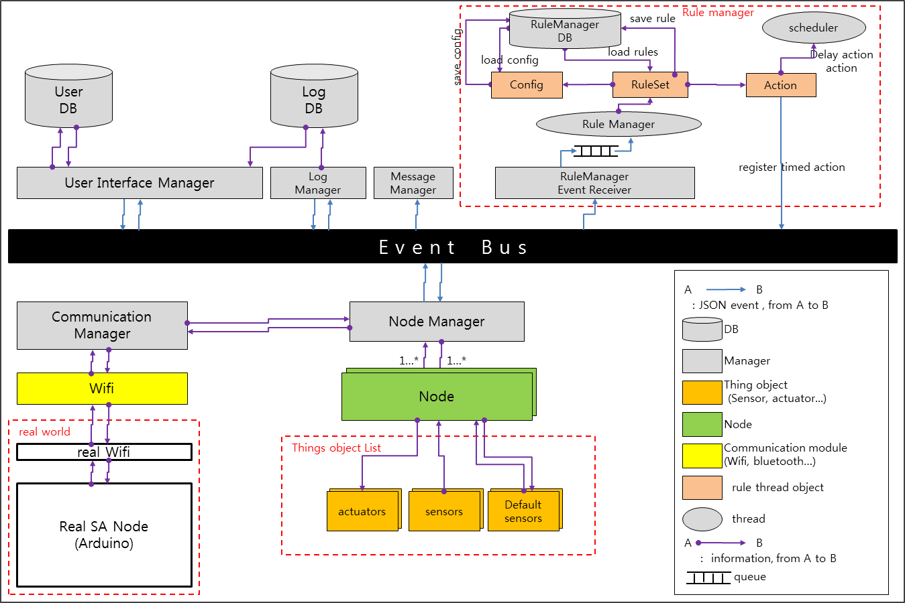
Figure 4. Dynamic view of overall system

전체 그림 약간 수정 필요. (위에거보다 간략하게 요약된 그림이 들어가고 위의 그림은 Sub-system으로 보내는 것도 괜찮을 것 같음)

각 Component에 대한 설명

Dynamic Behavior

Interfaces
Interface만 나와있는 약식 다이어그램. 프로토콜 정의문서

The reason why we are use JSON
3rd party HW개발자를 위해 뭐 썼다~?

The reason why we are using Event-Bus

The reason why we are using DataBase
Database(DB) server provides scalability. And using database makes management of data easy. Use of file is a good method for append data, but it is a bad method for searching. Therefore using database make advantage for data management.
We can use SQL DB and NoSQL. Because of common interface, we decide using SQL Server. We apply ODBC library. So we can change SQL Database such as MySQL, MariaDB, MSSQL, PostgreSQL and so forth. In additionally, when we get DB storage trouble (probably it is the reason why disk is full or read/write failure.), it seems to be capable to maintain this situation.

Tactics
있으면 쓰고~

Related Quality Attributes
QA-08: Logging history availability
when disk is full or read/write failure, we should inform to administrator. And we should manage and maintain this situation. So using Database is better than using file directly.

Physical Perspective

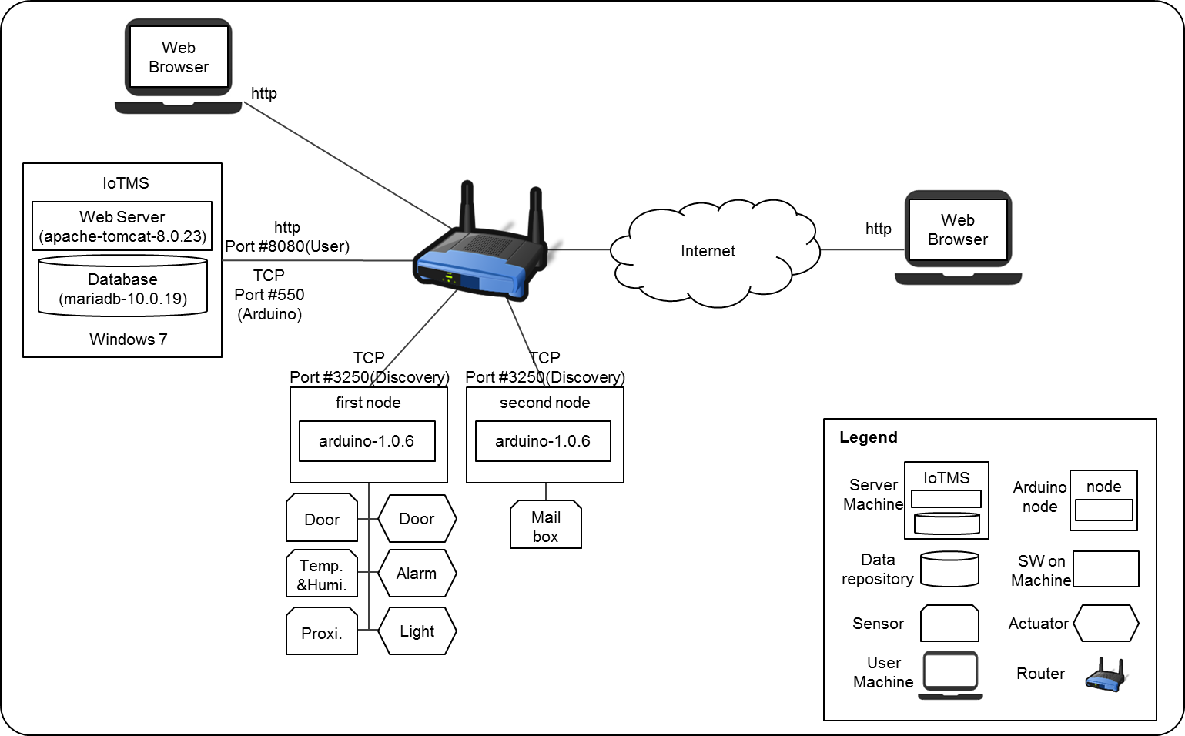
Figure 5. Allocation view of overall system

Allocation view describes physical environment of this solution. There is a router for wifi network. Under the wifi network, there are IoTMS, two nodes. And user can be attach the router, connect to IoTMS with the wifi. IoTMS is installed in laptop, which installed OS such as Windows 7. Two node have sensors and actuators. First node has sensors for door, temperature, humidity, proximate. In this node, proximate gets sense of exist of persons. And the node has actuators of door, alarm, light. Second node has sensor for mailbox. In IoTMS system environment, each system and device communicate with TCP/IP protocol. Between IoTMS and user, the protocol is http and their port is 8080. And between IoTMS and arduino nodes, the protocol is our defined TCP/IP protocol. It uses two ports as IoTMS listen port(550) and arduino listen port(3250).

Design Rationale of Physical Perspective

The reason why we are using web server
웹 서버는 왜 썼고, 톰캣은 왜 썼나?
We got requirement of web UI. Therefore we serve http protocol. In our technical constraint, we should use Java language. So we considered Java web project solution. There are many web development solutions such as tomcat, websphere, jetty and so forth. Of cause we can develop http response but this method is not extendibility. So we apply web server solution and especially tomcat. Each solution has own advantage but tomcat has many references. So we use tomcat.

The reason why we are using Maria DataBase
왜 마리아 DB를 썼나용?
MariaDB with all flavors of Linux, UNIX, and Windows being supported. And, of course, the open source nature of MariaDB allows complete customization for those wanting to add unique requirements to the database server. MariaDB is likely to MySQL. Even though ODBC library is same because same team makes both database. But MariaDB is newly DB.

Develop Environment
Server side
Language : JAVA (jdk-1.8.0)
Database : mariadb-10.0.19
Web Server : apache-tomcat-8.0.23
IDE : eclipse-jee-luna-SR2 (Spring-4.0.4, Guava-18.0, JSON Simple-1.1.1)

Arduino side
IDE : Arduino-1.0.6

Tactics
있으면 쓰고~

Related Quality Attributes

Decomposition of System Architecture Design
In this section, we describe decomposition of system architecture design on each views.

Dynamic view of Overall system

Dynamic view of overall system

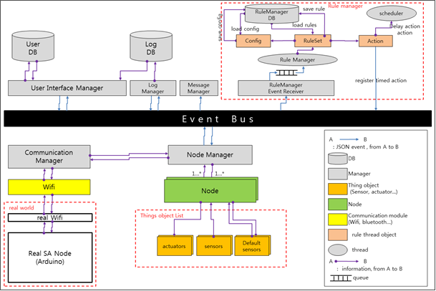
Figure 6. Dynamic view of overall system

Describe elements
Element | Description
Table 24. Description of each elements

Architecture design of Model
Model includes NodeManger, RuleManager,

NodeManager
NodeManager’s Role is that

Static Perspective

Dynamic Perspective

Communication Diagram of registerNode
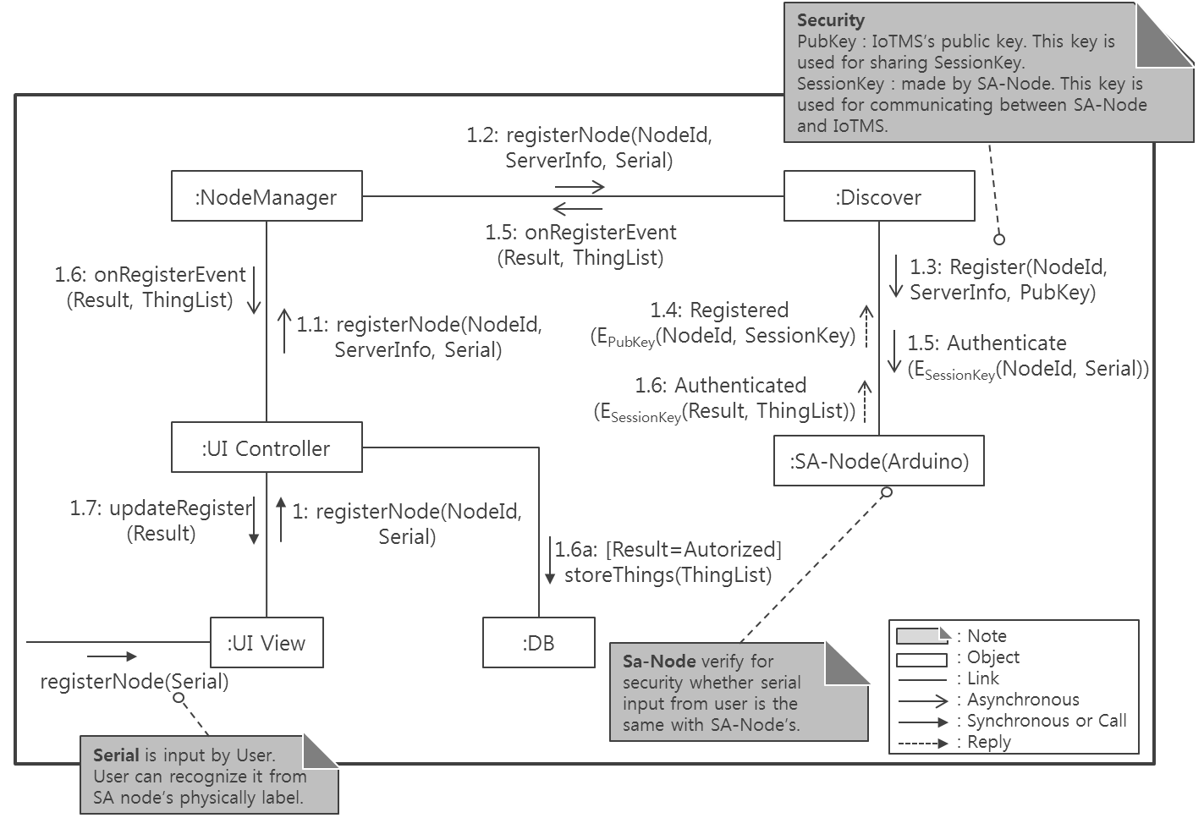
Figure 7. Communication Diagram: registerNode

Describe elements

Communication Diagram of addNode

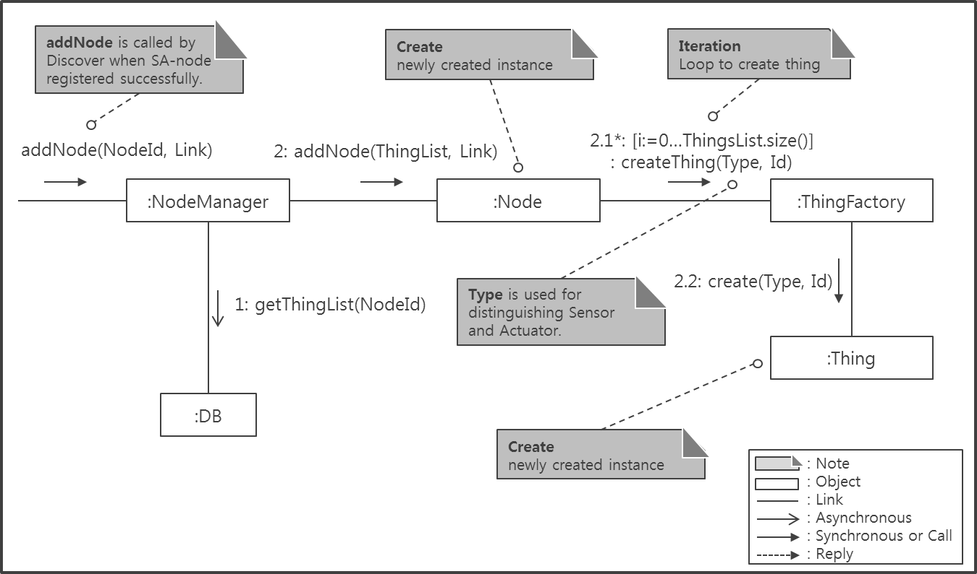
Figure 8. Communication Diagram: addNode

Describe elements

Design Rationale

Related quality attributes

Architecture Design of RuleManager

Static Perspective

Dynamic Perspective

Design Rationale

Related quality attributes

Architecture Design of Logger
Logger is responsible to store things value change event and user event. Also logger have to store alarm message and inform message such as malfunction and confirm of security setting.
Besides according to time elapse, logger have to delete old event log like sliding window.

Static Perspective
Below figure shows Logger’s static perspective.
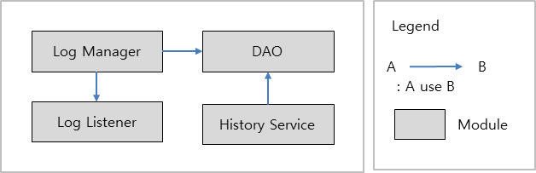
There are 4-modules.
Log Manager module use Log Listener and DAO. As we use event bus, Log Manager can get event of thing value and user command with Log listener. And Log Manger store the events into Database with DAO.
Log Listener module is responsible to get events and inform Log Manager to get events.
DAO module provides database access. So Log Manager can store events into database
History Service is responsible to erase old event log like sliding window with DAO.

Dynamic Perspective

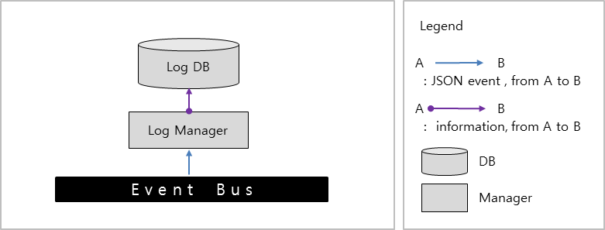

Basically, Log Manager gets event through event bus, and stores event into Log DB. More detail actions is below.
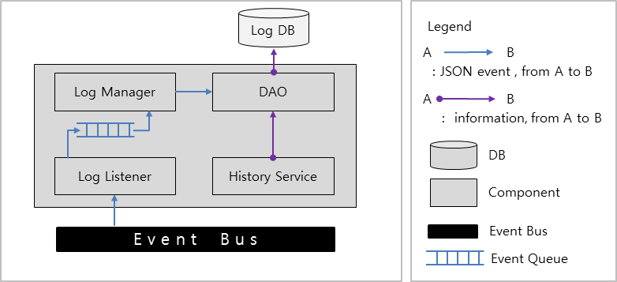

Initially Log Manager has Log Listener and DAO. Log Listener gets events and put the events into event queue of Log Manager. And Log Manager store events into Database with DAO. Also History Service use DAO. Actually History Service transfer SQL Query information to DAO. So DAO transact this SQL query. SQL Query is about delete query and History Service request query execution every minute because of remove events over duration of log.

Design Rationale
Event Queue is necessary because of transaction delay. DAO has database I/O and it is slower operation than event emerging. Once Log Listener gets events, then lots of events can be reached. Events wait for Database transaction. So we make event queue for transaction waiting.
Every minute History Service request delete query execution. Stored events is kept for duration of log time. We should decide when delete past logs. It can be the time when arrive new log or periodic time. If logs are delete at arrival time of new log, we leave logs over duration time. So clearly periodic time interval is better. And then we should determine how much frequent do we transact query. If we have shot interval, then performance will be getting bad. When we see watches, we see hours and minutes. Generally we don’t see seconds(Of cause, there are case of seeing seconds). So we decide that duration time have minutes at least and that periodic time interval is one minute.

Related quality attributes

Architecture Design of Message
Message is responsible to send messages to user by E-mail, twitter and so on. When emerging security alarm or malfunction or confirm security setting, then IoTMS sends defined message.
Before sending message, user should store E-mail address or twitter account. Especially user twitter account have to follow @swarchitect_cmu.

Static Perspective
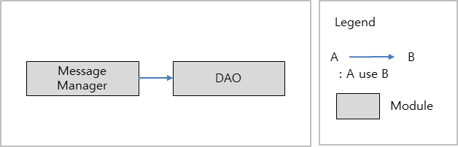

Dynamic Perspective

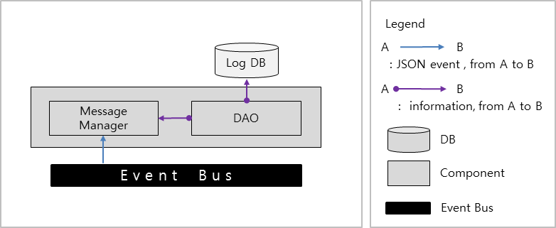

Design Rationale

Related quality attributes

Architecture Design of UI and UI Controller

Static Perspective

Dynamic Perspective

Design Rationale

Related quality attributes

Architecture Design of Communication

Static Perspective

Dynamic Perspective

Design Rationale

Related quality attributes

Architecture Design of SA-Node

Static Perspective

Dynamic Perspective

Design Rationale

Related quality attributes

Security

Secure communicate between User and User Interface
IoTMS is accessed by Web browser or Application. But IoTMS should be response securely. So IoTMS checks validation of user. Therefore user have to login with id and password.
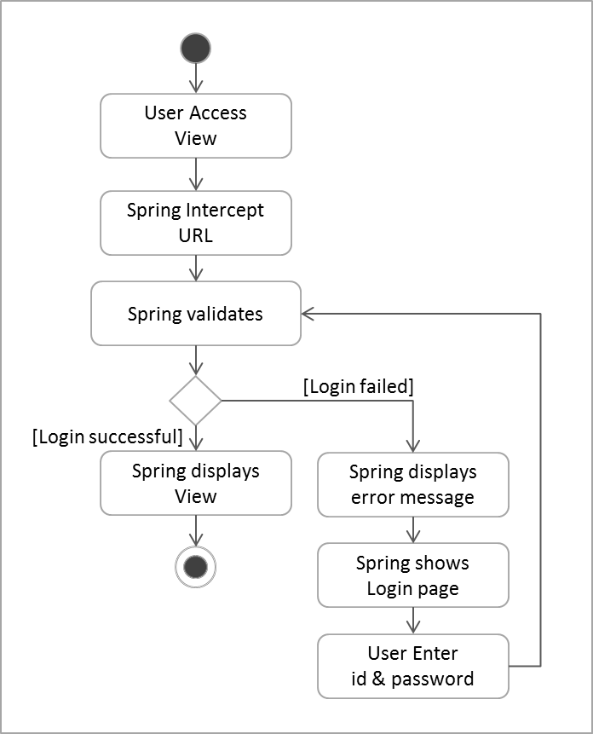

We can choose framework or organic development. Using framework, especially spring framework can filter user access with URL Pattern. And It uses access filter xml, so it applies user access control easily. But we should be necessary to study framework and it seems that studying framework is needed much time. In organic developing, if using cookie, It can develop simply. But we can apply just web page. According to implementation, it cannot apply at Web API and it is more chance to mistakes of developer. So we decide to apply framework method.

Secure communicate between IoTMS and SA-Node

Document Dictionary

Glossary
The glossaries in this document are described.
Glossaries | Description

Acronyms
The acronyms in this document are described.
Acronyms | Description

Index
문서 완료 후

